COLUMBARIUM MEMORIAL GROUNDS POLICIES
Regular cleaning and maintenance of a niche and Columbarium are crucial for preserving the dignity and beauty of these memorial spaces. Maintaining these spaces not only shows respect for those who have passed but also provides comfort to their families and friends.
FLOWERS, FLAGS, SIGNS, AND OTHER DECORATIONS
- Flower Vases. The only approved flower vases for use in the Columbarium are those that can be inserted in the spaces between the niches. The vases are available to borrow from the office during office hours.

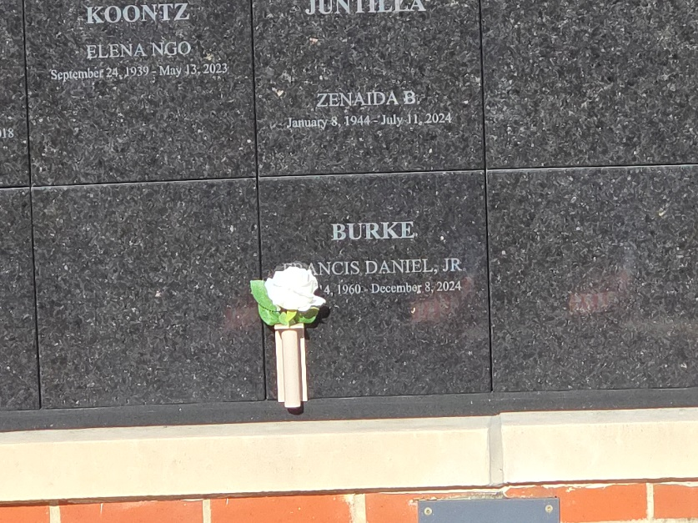

- Floral Regulations. Fresh cut flowers may be placed in the designated Columbarium area. Flowers will be removed as they expire and during the monthly cleaning of the Columbarium.

- Prohibited Ornaments. The placing of any item such as hazardous materials, glass containers or bottles, metal, toys, pictures, candles, electric or battery-operated lights, balloons, books, letters and signs is not permitted in or near the Columbarium area.

- The church also marks November 1, All Saints Day, as a decoration day for floral arrangements to be placed in the Columbarium. Such arrangements should be removed from the Columbarium no later than November 8.
- An American flag is allowed at the niche site for Memorial Day, Independence Day, and Veterans Day and may be displayed the day before through the day after the holiday.
F. No glass vases or containers may be placed on the wall or walkway.
- Prohibited items may be removed and disposed of by the Church without notice or liability to the owner of the item or any niche owner. The Columbarium Committee will clean the Columbarium on a monthly basis.

